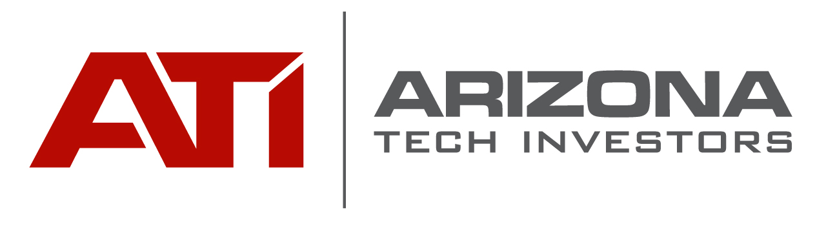

Arizona Tech Investors - Investment Candidate Template

Name of Company:____________________________________
Name of Executive:___________________________________

Bittner Formulation: We sell_____________________ to ____________________ in order to solve____________________. Unlike__________________________, our solution does_____________________ .

Preliminary: Solicitation Form
Have you taken any steps to do a general solicitation (as defined by Regulation D, Rule 506(c))?
Yes or No

Do you plan to do a general solicitation? Yes or No

If you answer Yes to either of these questions, please do not proceed as ATIF only considers opportunities offered via private solicitations.

- Problem
1-A: What is the problem you’re attempting to solve?
1-B: How painful is the problem to those that have it?

- Customers
2-A: Who has the problem?
2-B: How many have the problem?
2-C: What segment of them are you addressing first?
2-D: What other segments will you address later?

- Solution
3-A: What is your solution to the problem?
3-B: What benefit does it provide to your customer?

- Competition
4-A: Who are your competitors?
4-B: Why is your solution better than other solutions? How much better?

- Business Model
5-A: How will you make money?
5-B: What is the revenue potential for your solution over the next 3-5 years?
5-C: Does your product require a reimbursement code from third parties to reach commercial success? If so, describe your strategy and expected timing for obtaining such approval.

- Go-to-Market Strategy
6-A: How will you make your first sales? Be specific.
6-B: How will you market and sell your solution?
6-C: How will you produce and deliver your solution?
6-D: How will you support your sales?

- Product
7-A: What IP do you have?
7-B: What is your current state of development?
7-C: What milestones have you met?
7-D: What milestones do you have in the next 18 months?
7-E: What is your larger product development roadmap?
7-F: What is your supply chain for prototypes & small volume production?
7-G: How will you scale production? Who are your potential suppliers?
7-H: Who will manage supply, production, and distribution?

7-I: Does your product require regulatory approval for commercial sale? If so, please identify specifically what approval is required, where you are in the approval process, and how much time and capital are required to obtain that approval.

- Management
8-A: Who is your team?
8-B: How much cash has each founder and current executive invested in the company?
8-C: Why is your team right for the challenge?
8-D: What critical roles are unfilled today? How will you fill them?
8-E: Who are your advisors/board members? Are they investors?

- Strategy
9-A: What is your going forward strategy, plan and timeline?
9-B: What broader trends will help or hinder your success?
9-C: What are the three biggest risks that you perceive?

- Financial
10-A: How much cash do you have today?
10-B: What is your burn rate today?
10-C: How will you reduce your burn rate if funding is delayed?
10-D: What are your revenue projections and assumptions?
  - Next 12 months
  - Longer term
10-E: What are your income statement, balance sheet, cash flow
projections, and assumptions?
10-F: What are the three biggest drivers to success or failure?

- Capital Requirements
11-A: How much money have you received to-date? What are the sources?
11-B: Who are your shareholders? How much has each contributed to the company?
11-C: How much money are you requesting now and what will it be used for?
11-D: What additional money will you need in the future; from what source?
11-E: How will we exit?
11-F: What is your valuation of the company; how did you arrive at that value?
11-G: What is your proposed investor deal and forecast investment returns?

